OOP Lab 3 Report

Ex1:

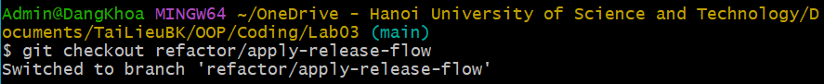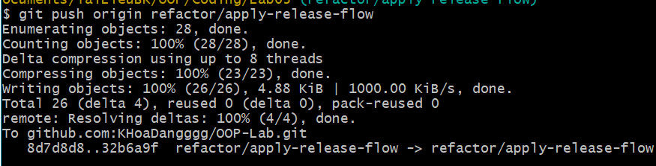

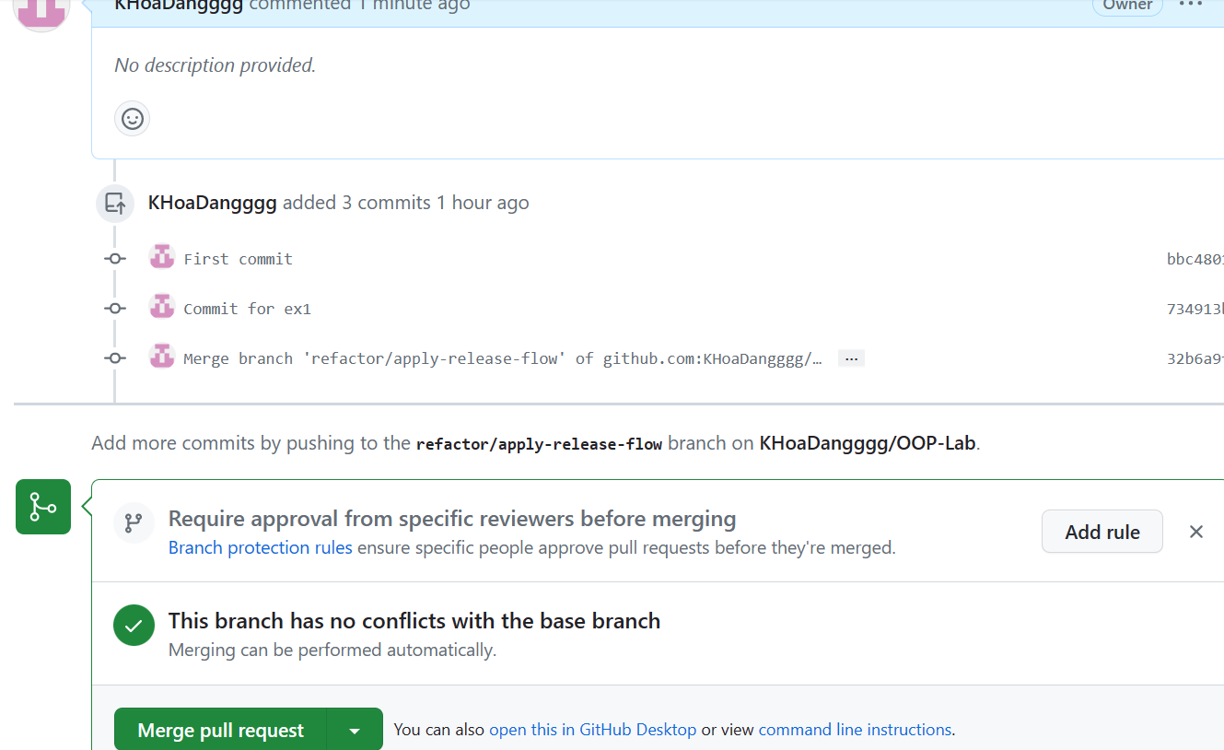

Ex2:

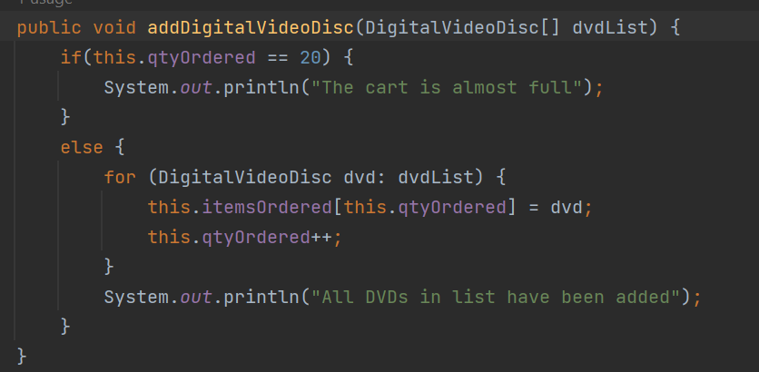

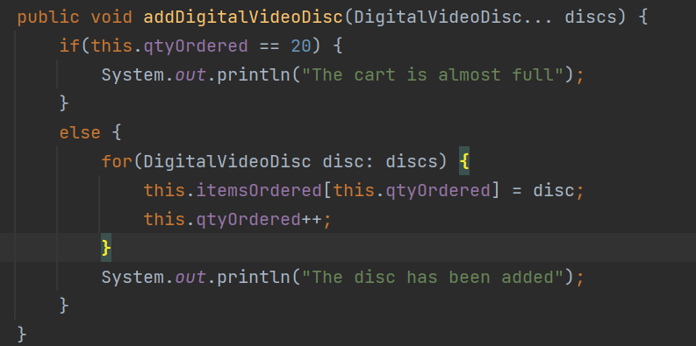

Ex3:

Ex4:

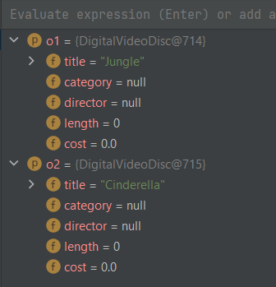 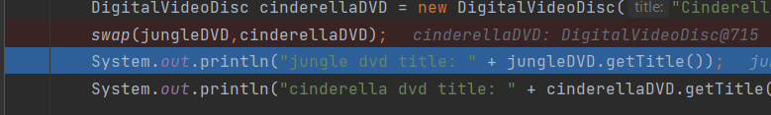

Ex5:

Ex6:

Ex7:

Ex8:

Ex9:

* String concanation

* Garbage creator

* GarbageCreater hang for a long time and can not run successfully.

* Garbage creater can run immediately after 236ms.
* GarbageCreater run slower than StringBuilder, but it took only 712ms.

NoGarbage

GarbageCollector take longer than 5s so it was terminated.

Ex10:

